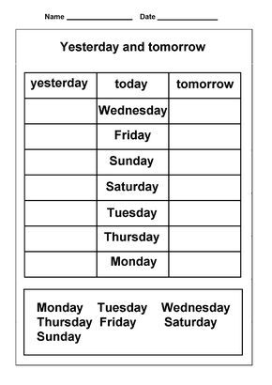
Months (complete)
January - ………………………………. – March - ………………………………………….
May - …………………………………… - July - ……………………………………..………..
September - ………………………………….. – November - ……………………………

