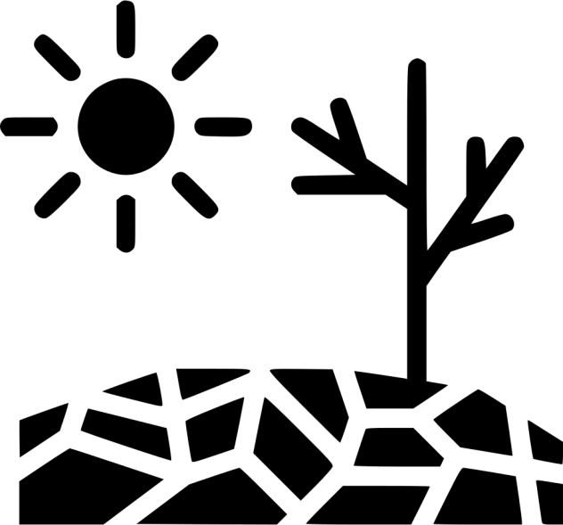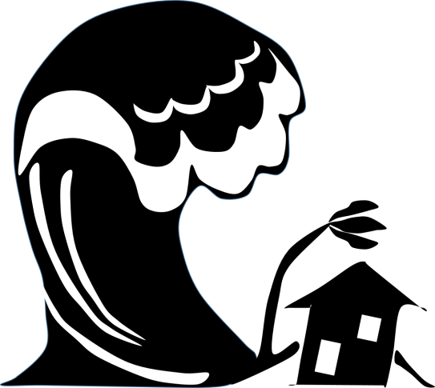***Natural disasters***

1. **What disaster is in the picture?**

***Word list: landslide, earthquake, tornado, wildfire, drought, blizzard, heat wave, flood, avalanche,***

***volcanic eruption, hurricane, tsunami.***

|  |  |  |
| --- | --- | --- |
| ÐÐ°ÑÑÐ¸Ð½ÐºÐ¸ Ð¿Ð¾ Ð·Ð°Ð¿ÑÐ¾ÑÑ Ð»Ð°Ð²Ð¸Ð½Ð°  1) __________________ | ÐÐ°ÑÑÐ¸Ð½ÐºÐ¸ Ð¿Ð¾ Ð·Ð°Ð¿ÑÐ¾ÑÑ heat wave  2) ___________________ | ÐÐ°ÑÑÐ¸Ð½ÐºÐ¸ Ð¿Ð¾ Ð·Ð°Ð¿ÑÐ¾ÑÑ volcano eruption  3) ___________________ |
| ÐÐ°ÑÑÐ¸Ð½ÐºÐ¸ Ð¿Ð¾ Ð·Ð°Ð¿ÑÐ¾ÑÑ earthquake  4) ____________________ | ÐÐ°ÑÑÐ¸Ð½ÐºÐ¸ Ð¿Ð¾ Ð·Ð°Ð¿ÑÐ¾ÑÑ drought  5) ___________________ | ÐÐ°ÑÑÐ¸Ð½ÐºÐ¸ Ð¿Ð¾ Ð·Ð°Ð¿ÑÐ¾ÑÑ hurricane  6) ___________________ |
| ÐÐ°ÑÑÐ¸Ð½ÐºÐ¸ Ð¿Ð¾ Ð·Ð°Ð¿ÑÐ¾ÑÑ natural disaster tsunami  7) _____________________ | ÐÐ°ÑÑÐ¸Ð½ÐºÐ¸ Ð¿Ð¾ Ð·Ð°Ð¿ÑÐ¾ÑÑ tornado  8) ____________________ | ÐÐ°ÑÑÐ¸Ð½ÐºÐ¸ Ð¿Ð¾ Ð·Ð°Ð¿ÑÐ¾ÑÑ wildfire  9) ____________________ |
| ÐÐ°ÑÑÐ¸Ð½ÐºÐ¸ Ð¿Ð¾ Ð·Ð°Ð¿ÑÐ¾ÑÑ blizzard  10) ___________________ | ÐÐ°ÑÑÐ¸Ð½ÐºÐ¸ Ð¿Ð¾ Ð·Ð°Ð¿ÑÐ¾ÑÑ flood  11) ____________________ | ÐÐ°ÑÑÐ¸Ð½ÐºÐ¸ Ð¿Ð¾ Ð·Ð°Ð¿ÑÐ¾ÑÑ landslide  12) ____________________ |

1. **What hazard does the sign warn about?**
2. 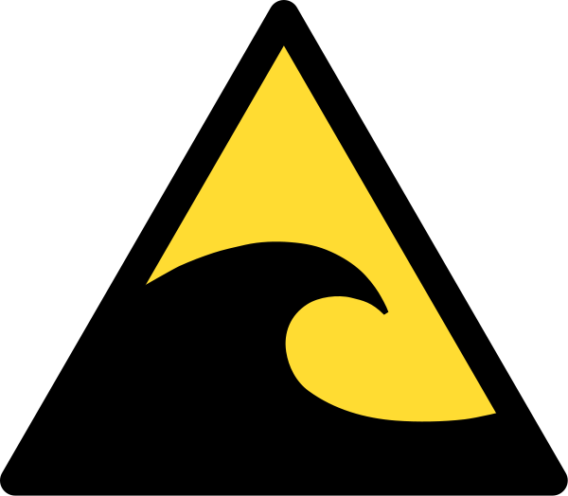 2) 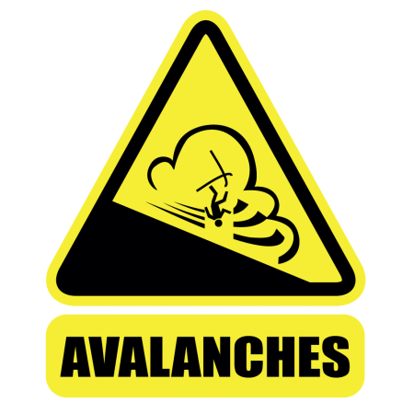 3) 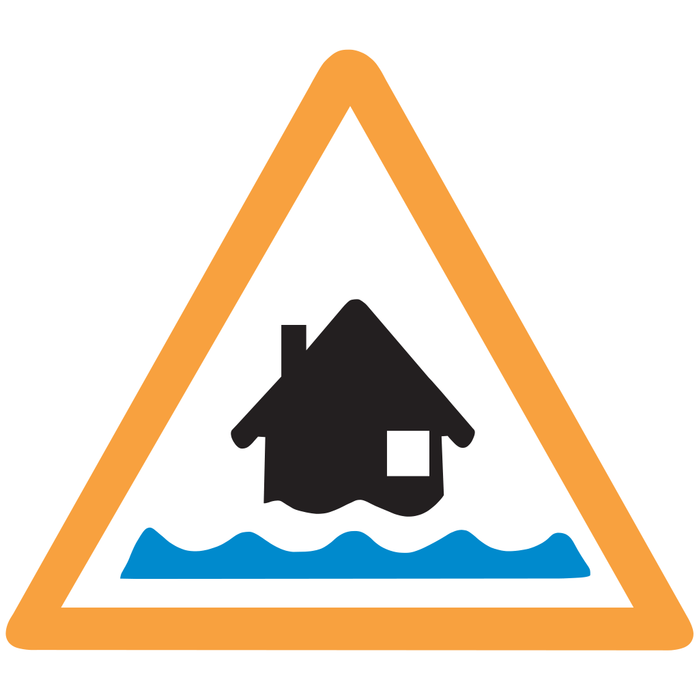 4) 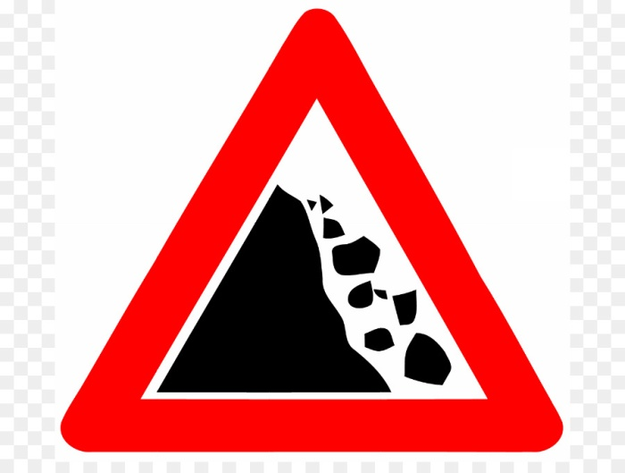

__________________

**warning sign**

__________________

**warning sign**

__________________

**warning sign**

__________________

**warning sign**

5) 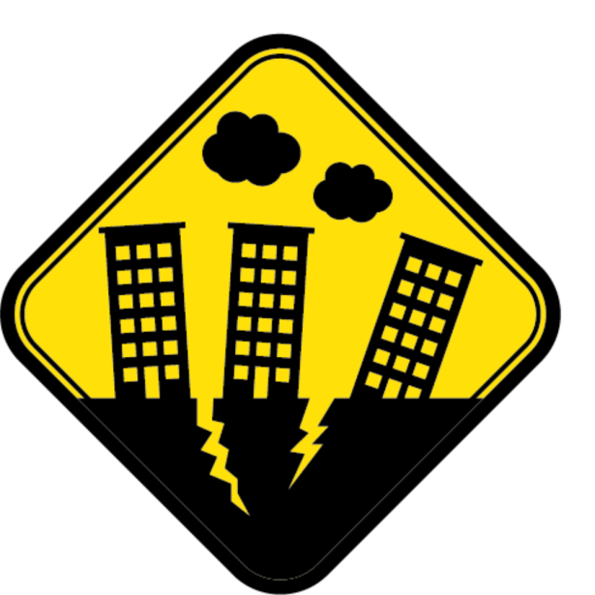 6) 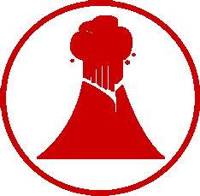 7) 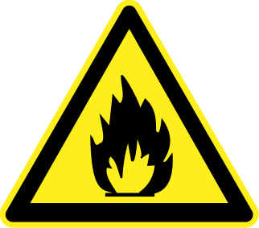 8) 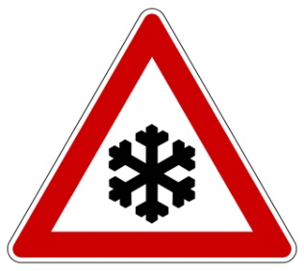

__________________

**warning sign**

__________________

**warning sign**

__________________

**warning sign**

__________________

**warning sign**