Date : | Name: …………………………………………………………………………… | Grade : … / …

- Look at the pictures, complete the sentences then watch the video and check your answers:
[happy – sad – hot – cold – scared – angry – hungry – sleepy – thirsty – sick]
1 | 2 | 3 | 4 | 5
6 | 7 | 8 | 9 | 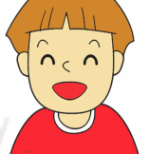  10
- He is hot.  - She is ……………… .  - She is ……………… .  - She …… …………… .  - He …… …………… . | - ……… …… ……………… .  - ……… …… ………………… .  - ……… …… ………………… .  - ……… …… ………………… .  10. ……… …… ………………… .

- Now, draw yourself and your friend then write sentences about your pictures:
1  ……………………………………………………… | 2  ………………………………………………………

Use this link to play the video and get students check their answers: https://www.youtube.com/watch?v=dNP5BzrBiOg

