1  Listen to the conversation in a café. Complete the sentences.
1 The hot dogs are £2.25.
2 Luc would like __________________________.
3 Luc’s lunch is £ _________________________.
4 Jess doesn’t want any ____________________.
5 A salad is £ ____________________________.
6 Jess would like _________________________.

 | _____ | 10
2 Read the texts about Finley’s and Olivia’s towns. Answer the questions.
Finley
I live in the centre of Rompton. It’s a small town, but I like it! I live next to an Indian restaurant. We sometimes have lunch there, and the food is delicious! There are a lot of shops near my house, and there’s a supermarket, too. My town hasn’t got a cinema, but it’s got a great library. I can borrow DVDs and ebooks from the library – it’s my favourite place. My school is very near my house, so I can walk there. Some of my friends go by car.

Olivia
I live in Flatterly, but I don’t live in the centre of the town. I live opposite the hospital I get the bus to school because it’s too far to walk. There’s a shopping centre near my house, too. There’s a cinema in the shopping centre, and I sometimes go there with my friends. In the centre of town there are a lot of shops, some restaurants and a library. My town has got two swimming pools, but one only opens in the summer. The summer swimming pool is my favourite place in Flatterly.
1 Where is the Indian restaurant?
It’s next to Finley’s house.
2 What is Finley’s favourite place?
___________________________________.
3 How does Finley go to school?
___________________________________.
4 How does Olivia go to school?
___________________________________.
5 Where is the cinema?
___________________________________.
6 How many swimming pools has Flatterly got?
___________________________________.

 | _____ | 10
3 Match the sentence halves.
1 There's f
2 There aren't ___
3 Is there ___
4 There isn’t ___
5 Are there ___
6 There are ___

a any trees near your house?
b a museum in my town.
c some dodgems at the funfair.
d a desk in your room?
e any clothes in the wardrobe.
f a trampoline in my garden.

 | _____ | 5

4 Complete the sentences with the prepositions below.
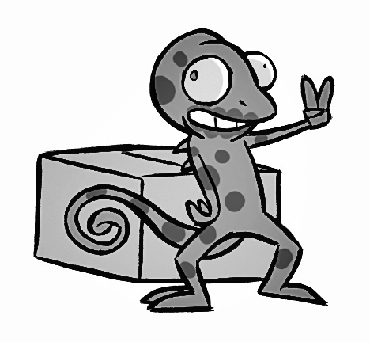
behind next to in in front of on opposite

1 Chris is in front of the box.
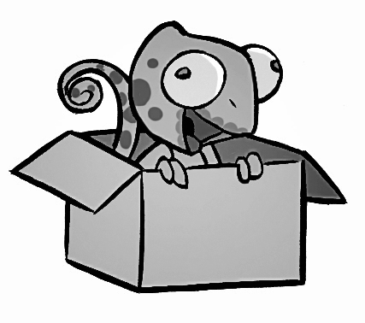

2 Chris is ____________ the box.

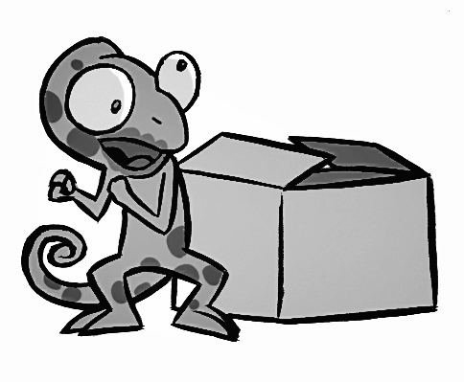
3 Chris is ____________ the box.
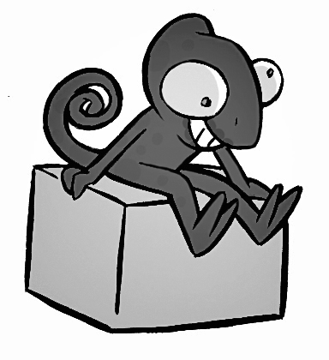
4 Chris is ____________ the box.
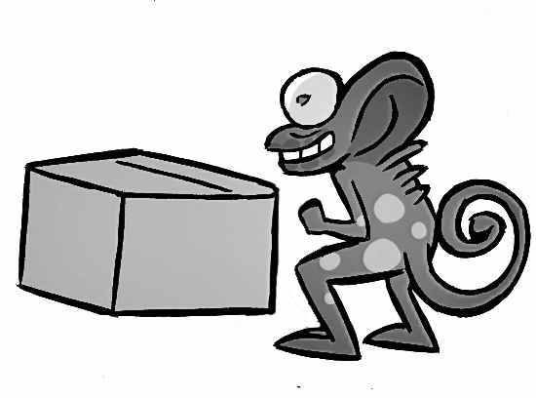
5 Chris is ____________ the box.
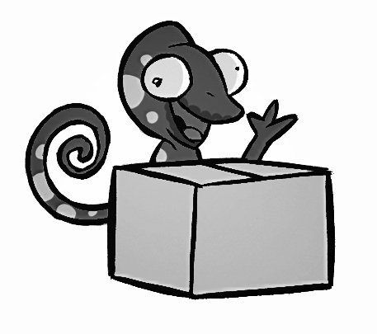
6 Chris is ____________ the box.

 | _____ | 5
5 Put the words in the correct order to make questions.
1 go / Where / your / school / sister / does / to
Where does your sister go to school?
2 collect / What / Harry / does
___________________________________?
3 eat / does / What / turtle / your /
___________________________________?

4 basketball / your / do / play / Where / friends
___________________________________?
5 get / early / Why / Anya and Susie / up / do
___________________________________?
6 next / school / Who / sit / do / to / at / you
___________________________________?

 | _____ | 5
6 Match the words 1–5 with the words A–F to make places at the funfair.
1 hot dog c a coaster
2 big __ b shy
3 candyfloss __ c stand
4 coconut __ d stand
5 ghost __ e train
6 roller __ f wheel

 | _____ | 5
7 Complete the definitions with the words below.
boat bus car motorbike plane tram
1 A bus has got four or six wheels, and it takes a lot of people from one place to another.
2 A ____________ has got wings, and it flies.
3 A ____________ has got four wheels and it goes on the road.
4 A ____________ hasn’t got wheels, and it goes on the water.
5 A ____________ got two wheels, and it can go very fast.
6 A ____________ has got a lot of wheels, but it doesn’t go on the road.

 | _____ | 5

8 Complete the dialogue with the phrases below.
Here you are Here’s How much are
How much is Thanks would you like
A Hello. What 1would you like?
B 2 ______________________ the chicken sticks?
A £2.80 for four.
B 3 ______________________ a bag of chips?
A £2.50 for a small bag. £3.50 for a big bag.
B 4 ______________________. I’d like eight chicken sticks and a small bag of chips, please.
A 5 ______________________. That’s £8.10.
B Thanks. Here you are.
A 6 ______________________ your change.

 | _____ | 5

 | Total |  | 50

