GOOD LUCK
1 PAST IN ENGLISH: past simple, past continuous
Example: I played (play) tennis yesterday. She was working (work) in the garden at 5 pm yesterday.
1 While I ______________ (drive), I _______________(have) an accident.
2 Alan _____________(look) out of the window when he_______________ (see) a UFO.
3 While we___________ (clean) the house, we____________ (break) some glasses.
4 What _____________(they/do) at 10pm last night ?
5 Last night I __________(lose) my keys .
6 I _____________(work) in the garden at 3 pm yesterday.
7 Last month I ___________(not go) to Scotland.
8 When ________you ________(get up) yesterday?
9 Jenny _________(not be ) ill last week.
10 I ____________(not drink) three cups of coffee at 7 am last night.
2) PRESENT IN ENGLISH (present simple or present continuous tense)
Example: Tom walks (walk) to school every day. I am listening (listen) to music now.
1.I _________________(read) a book every evening.
2. Nick _______________(do) his homework now.
3. At the moment they ________________(not sit) in the café.
4.Look ! My cats __________________(sleep) now. 5. We usually________________(go) to school at 7.30.
6. Jenny _____________(not watch) TV in the afternoon.
7. Her friend ____________(not play) the violin but she ________(play) the saxophone.
8. His sister normally ______(have) a piano lesson on Fridays but this week she______(go) swimming.
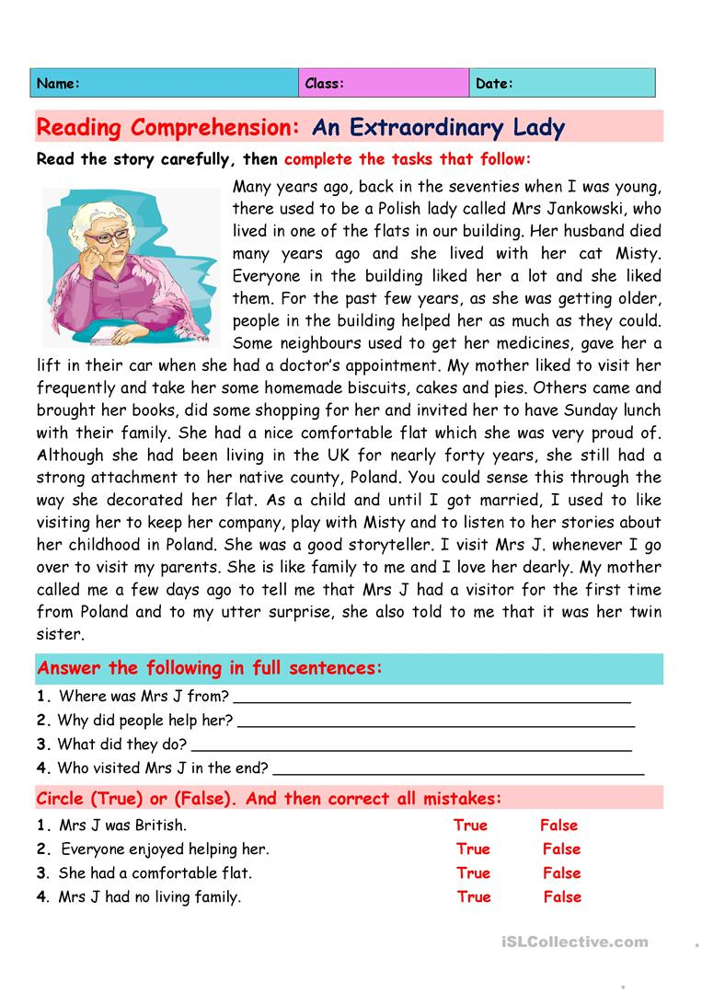

BONUS – DOBROVOLNÉ CVIČENÍ - Translation:

Včera jsem ztratil klíče. ____________________________________
Poslouchej! Marek zpívá. ____________________________________
Kdo bydlí ve městě? ________________________________________
Zatímco jsem spal, někdo rozbil okno. ________________________________________
Co Lucy dělala minulý týden? __________________________________________
Myslím, že zítra bude sněžit. _________________________________________
Katy čeká miminko příští měsíc. ____________________________________________

