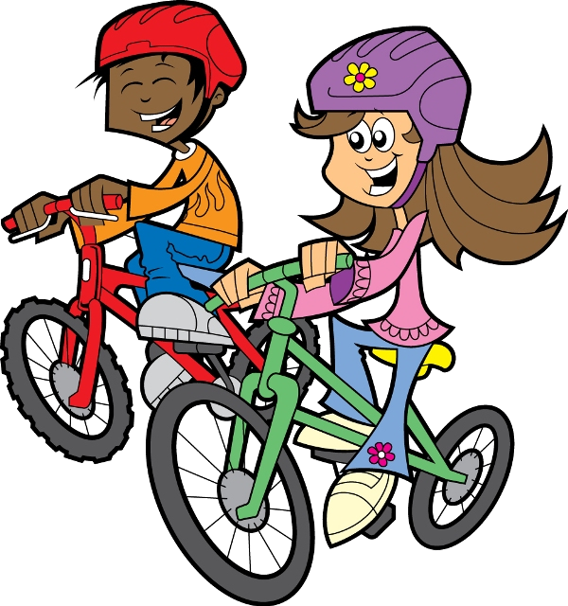
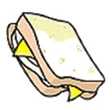
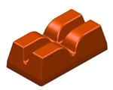
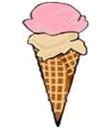

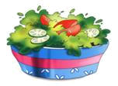
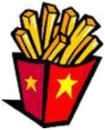
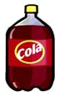
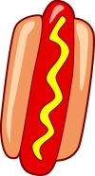


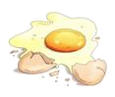
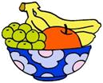
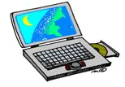
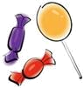
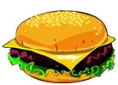
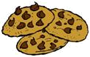
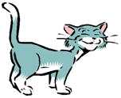
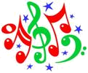

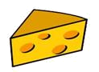
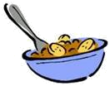

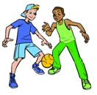
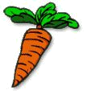
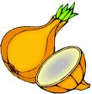

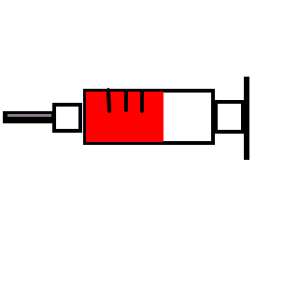
Likes & Dislikes
Writing, Grammar and Vocabulary
I LIKE...
I LIKE...
I DON’T LIKE...
I DON’T LIKE...
Albert likes cats. ( )
Albert doesn’t like eggs. ( )
Albert likes cola drinks. ( )
Albert likes French fries. ( )
Albert doesn’t like dogs. ( )
Albert likes math. ( )
Albert doesn’t like fruit. ( )
Albert likes soccer. ( )
Albert doesn’t like hot dogs. ( )
Albert likes hamburgers. ( )
Albert likes carrots. ( )
Albert likes donuts. ( )
Alice
Albert
Alice likes salad. ( )
Alice doesn’t like milk. ( )
Alice likes popcorn. ( )
Alice doesn’t like TV. ( )
Alice likes music. ( )
Alice likes candy. ( )
Alice doesn’t like chocolate. ( )
Alice likes computers. ( )
Alice doesn’t like onions. ( )
Alice likes ham and cheese. ( )
Alice likes coffee. ( )
Alice likes cheese. ( )

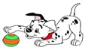

Mark T (true) or F (false) according to the picture:

