1. Listen and number Look and write.
3
2
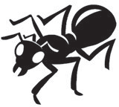
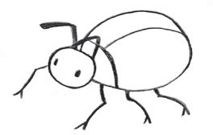
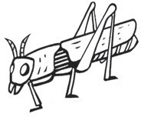
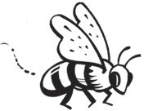
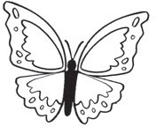
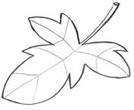
grasshopper ant beetle butterfly leaf bee

3. Read and circle.

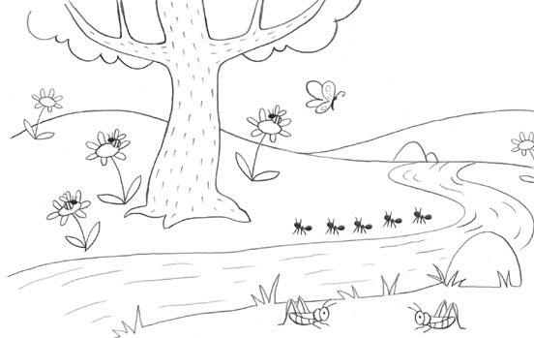

- I can see a grasshopper / butterfly. It can fly.
- There are 5 ants / bees.
- There are 3 beetles / bees on the flowers.
- There are 2 grasshoppers / beetles in the grass.

4. Write the words:

shoes boots jumper shorts hat dress

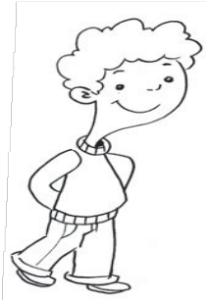
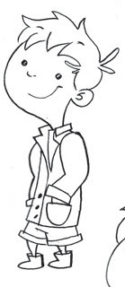
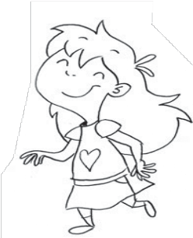
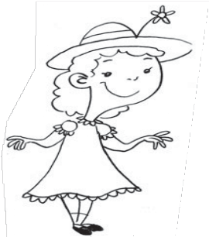
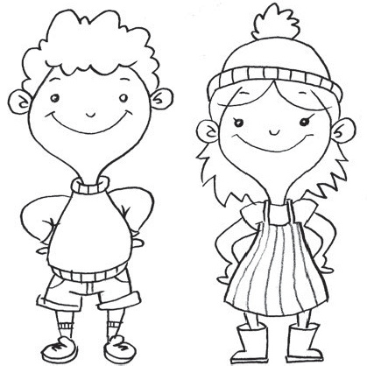
5. Read and ✓ or ✗.

1 2 3
4 1 I’m wearing shorts.
- I’m wearing a skirt.
- I’m wearing a jacket.
- I’m wearing a dress.

6. Look and write.

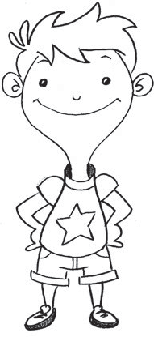
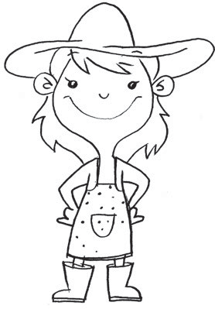
I’m wearing a
    - h and a
    - dr .
I’m wearing
    - b t .
I’m wearing a
    - T-s _ _ _ _ and (5) sh s.

