Direction: Write the sentence following the picture
This is / These are

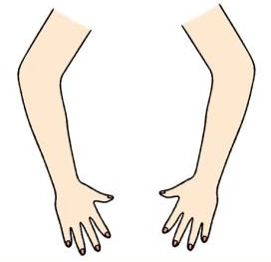
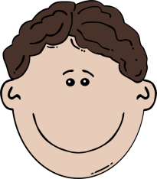
e.g.
This is my head. These are my arms.

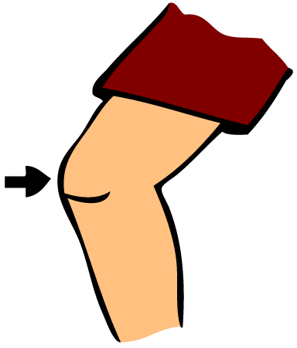
*-*-*-*-*-*-*-*-*-*-*-*-*-*-*-*-*-*-*-*-*-*-*-*-*
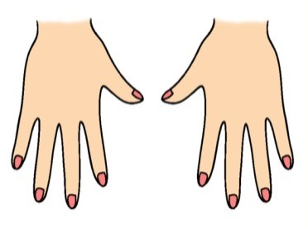
1. 2.

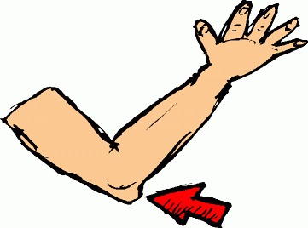
These ……………….. my fingers. This is my …………………….
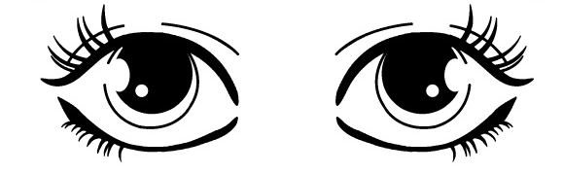
3. 4.

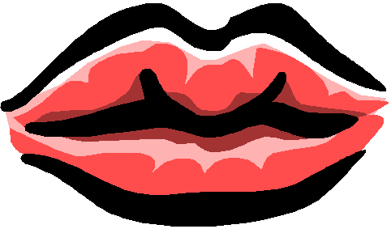
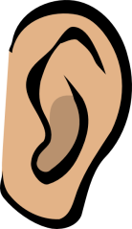
……………….. is my ……………………. ……………….. are my …………………….
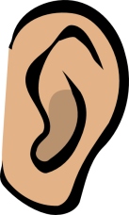
5. 6.

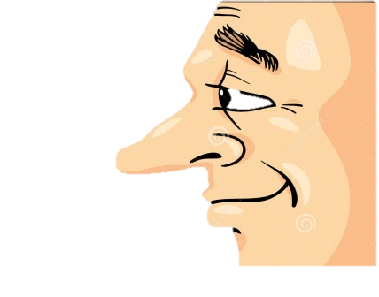
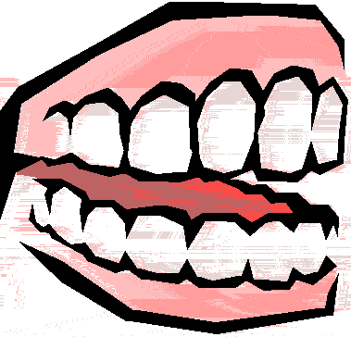
These……………….. my ……………………. This ……………….. my …………………….
7. 8.

………….…. ….………… my ………………… ……….….…. ….….… ……..… …………….…
Name………………………………………………………………………………………………………. No…………..……….. Class ……..…………….

