**PAST SIMPLE**

**Speaking cards**

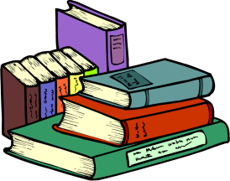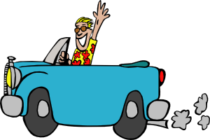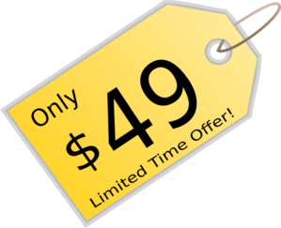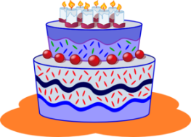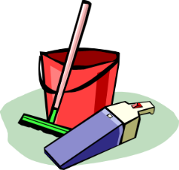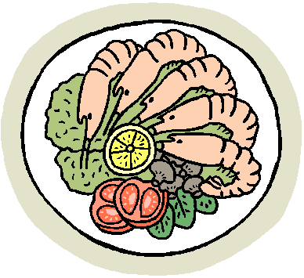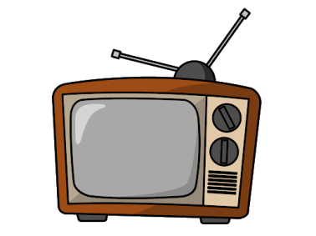

**VACATION**

* **Where did** you go on your last vacation?
* **How did** you go there?
* **What did** you do?
* **What did** you see?

**READING**

* **Did** you read a book last month?
* **What was** it about?
* **Did** you like it? Why?

**BIRTHDAY**

* **Where did** you celebrate your last birthday?
* **How many** friends **did** you invite?
* **What** presents **did** you get?
* **What did** you eat and drink?

**SPORT**

* **Did** you go jogging in the morning?
* **Did** you go skiing last winter?
* **Did** you swim last summer?
* **Did** you train yesterday?

**HOUSEWORK**

* **Did** you clean your room last Friday?
* **Did** you water any plants yesterday?
* **Did** you iron yesterday?

**TV**

* **Did** you watch TV yesterday?
* **What did** you watch?
* **What was** it about?
* **Did** you watch it alone?

**FOOD**

* **Did** you drink 3 cups of coffee yesterday?
* **What did** you eat 2 hours ago?
* **Did** your mum cook yesterday?
* **Did** you eat any fish

last week?

**SHOPPING**

* **Did** you go shopping last week?
* **What did** you buy?
* **Did** you go shopping alone?
* **How much did** you spend?

**INTERNET**

* **Did** you send any e-mails 1 hour ago?
* **Did** you chat online yesterday?
* **Did** you watch any videos on

the Internet yesterday?