REVISION – Unit 3, 4, 5
1. Listen to Amy and Leo talking about their best holidays. Answer the questions.
Example: Where was Leo in July?
He was in Spain.
1 How long was he there for?
______________________________.
2 What was his favourite sport?
______________________________.
3 When was Amy in Switzerland?
______________________________.
4 Why was she there?
______________________________.
5 What was her favourite sport?
______________________________.
2. Read about a trip around the world. Answer the questions.
Nelly Bly worked as a journalist for the American newspaper, the New York World. Her real name was Elizabeth Jane Cochran. On November 14, 1889, she went on a trip around the world for the newspaper. She wore a long dress and a coat, and she only had a small bag with her. First she went from New Jersey (USA) to Southampton (UK) by boat. She was very ill while she was at sea. From England, she went to France, and she visited Jules Verne, the author of the book Around the World in Eighty Days. She travelled through many countries, including Italy, Egypt and Hong Kong, and then she went to Japan. She loved the beautiful clothes there. Nelly's trip home was very long: she had to cross the Pacific Ocean, and she was on a boat for two weeks. She arrived in San Francisco on January 21. But Nelly wanted to do her trip faster than the people in Jules Verne's book, and she was late. The director of the newspaper paid for a private train to take her back to New Jersey. She arrived on January 25, 1890 after travelling for 72 days. Nelly Bly was the first woman - and the fastest person then – to travel around the world.

- What did Nelly have with her on her trip?

_____________________________________

2 How long did the people in Jules Verne's book take to travel around the world?

_____________________________________
3 What was the last country she visited and what did she like about it?
_____________________________________
4 How did she go from San Francisco to New Jersey?
_____________________________________
5 How much faster was Nelly's trip around the world than the people in Verne's book?
_____________________________________

3. Write the sentences in the past simple.
Example: We stay at a campsite every summer.
Last summer we stayed at a campsite.
1 Mia sees her friends every day.
Yesterday________________________
2 I don't usually have a sandwich for lunch.
Yesterday________________________
3 My friends go to the beach every year.
Last year_________________________
4 We don't visit my grandparents every week.
Last week________________________
5 Alex doesn’t often walk to school.
Yesterday________________________
4. Write questions for the answers. Use different question words for each sentence.
Example: What did you learn at the holiday club?
I learned about butterflies at the holiday club.

1_________________________________ home?
Sam arrived home at 7.00.

2 _______________________________ to Paris?
Linda and Susie travelled to Paris by train.
3 ___________________________ last weekend?
Ellie went to the mountains last weekend.
4 ____________________ on holiday ________?
Ben went on holiday with his family.
5 ___________________________ the museum?
We visited the museum after lunch.
5. Use the words to write sentences with the past of be.
Example: yesterday’s exam / difficult
Yesterday’s exam was difficult.
1 we / not at home last night
________________________________
2 your brother in the last race?
________________________________
3 they / at the sports shop last weekend
________________________________
4 I / not very happy last week
________________________________
5 you on holiday in July?
________________________________
6. Rewrite the sentences. Use the opposite adjectives.
Example: Centipedes are faster than millipedes.
Millipedes are slower than centipedes.
1 Bees are hairier than wasps.
Wasps______________________________________.
2 Mice are smaller than rats.
Rats________________________________________.
3 Buffalo are heavier than warthogs.
Warthogs____________________________________.
4 Butterflies are prettier than mosquitoes.
Mosquitoes_______________________
____________.
5 Giraffes are taller than ostriches.
Ostriches____________________________________.

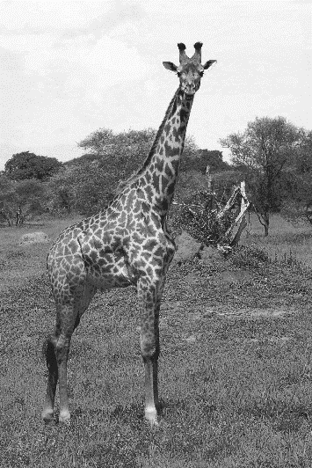
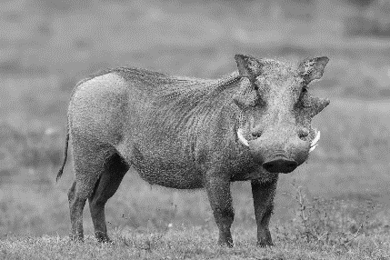
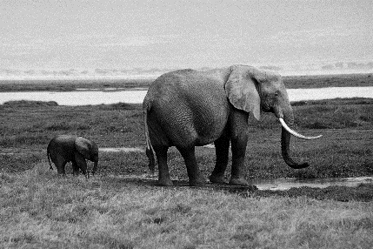

7. Write sentences about the animals. Use the superlative form of the adjectives.

Example: (pretty) Giraffes are the prettiest.
1 (heavy) ______________________________
2 (small) _______________________________
3 (tall) ________________________________
4 (ugly) ________________________________
5 (slow) ________________________________

