1 Listen to Amy and Leo talking about their best holidays. Answer the questions.
Example: Where was Leo in July?
He was in Spain.

1 How long was he there for?
______________________________.
2 What was his favourite sport?
______________________________.
3 When was Amy in Switzerland?
______________________________.
4 Why was she there?
______________________________.
5 What was her favourite sport?
______________________________.

2 Read about a famous race. Answer the questions.

The Boat Race is a famous race in the UK. It's a rowing race between Oxford University and Cambridge University. Both teams wear blue: Oxford wears dark blue and Cambridge wears light blue. The rowers are students, and there are eight rowers and a cox in each team. The cox is the person who tells the rowers which way to go.
The first boat race between Oxford and Cambridge was in 1829. The Oxford rowers were the winners. In the past, the race was only for men, but today there are two races every year; one for women and one for men. The races are on the last Sunday in March or the first Sunday in April.
The Boat Race is always on the same part of the River Thames in London. The start is at Putney Bridge, and the finish is 6.8km further up the river near Chiswick Bridge. On the day of the race, there's always a big crowd. More than 250,000 people watch the race from the side of the river, and another 15 million watch it on TV.

Example: How many teams are there in the Boat Race?
There are two teams.
1 How many people are there in each team?
________________________________________________________________
2 What is different about the Boat Race today?
________________________________________________________________
3 Which day is the Boat Race always on?
________________________________________________________________
4 Which part of the River Thames is the Boat Race on?
________________________________________________________________
5 Where do most people watch the Boat Race?
________________________________________________________________

10

3 Rewrite the sentences. Use the opposite adjectives.
Example: Centipedes are faster than millipedes.
Millipedes are slower than centipedes.
1 Bees are hairier than wasps.
Wasps______________________________________.
2 Mice are smaller than rats.
Rats________________________________________.
3 Buffalo are heavier than warthogs.
Warthogs____________________________________.
4 Butterflies are prettier than mosquitoes.
Mosquitoes_______________________
____________.
5 Giraffes are taller than ostriches.
Ostriches__________________________________
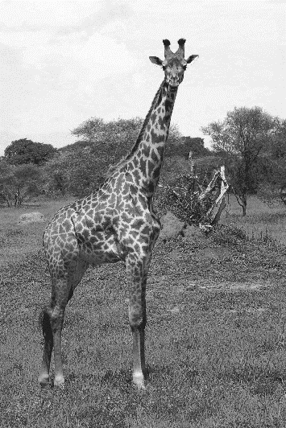
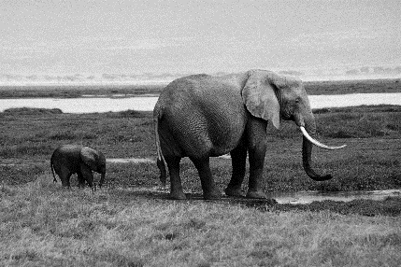
4 Write sentences about the animals. Use the superlative form of the adjectives.

Example: (pretty) Giraffes are the prettiest.
1 (heavy) ______________________________
2 (small) _______________________________
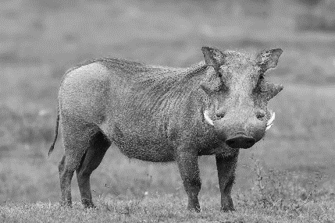
3 (tall) ________________________________
4 (ugly) ________________________________
5 (slow) ________________________________
5 Use the words to write sentences with the past of be.
Example: yesterday’s exam / difficult
Yesterday’s exam was difficult.
1 we / not at home last night
________________________________
2 your brother in the last race?
________________________________
3 they / at the sports shop last weekend
________________________________
4 I / not very happy last week
________________________________
5 you on holiday in July?
________________________________
6 Complete the dialogues with the words in the box.
hurt hurts I’ll pain shall I would you like
A Are you all right?
B No, I’m not. My ankle hurts.
A 1 ___________ help you stand up?
B Yes, please.

A What’s the matter?
B I’ve got a 2___________ in my stomach.
A 3 ___________ take you to the doctor.
B No, it’s OK. I’m fine.

A Are you feeling better?
B Yes, but my knees 4 ___________.
A 5 ___________ to sit down?
B Yes, that’s a good idea.

5

