<https://www.youtube.com/watch?v=XX_sPgvYSCI>

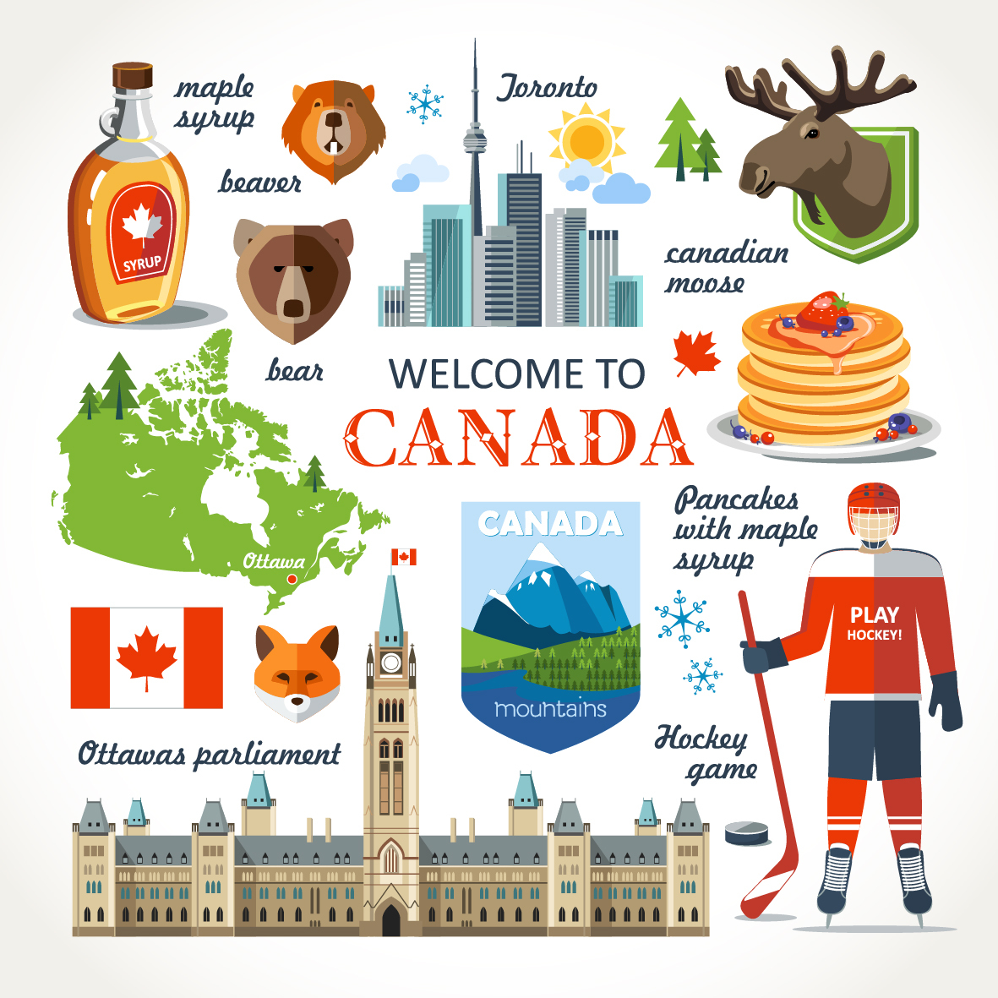

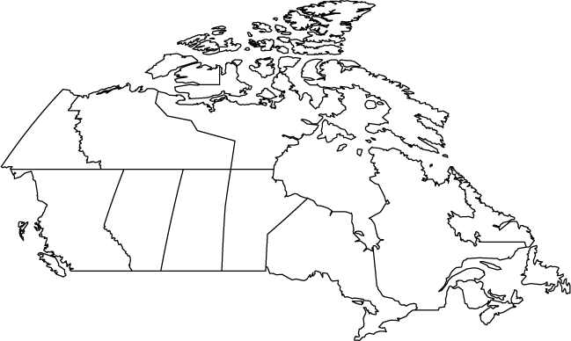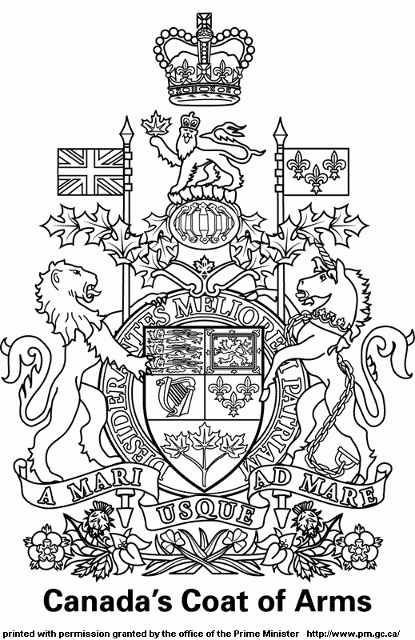Canada

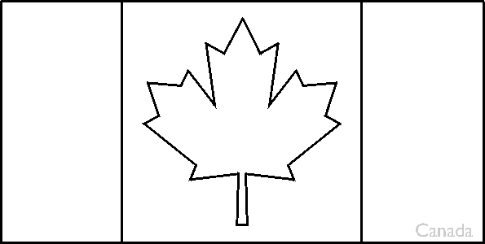

Leaf = ………………………………………………

Capital : …………………………………………………………

Type of government : …………………………………………….

Number of provinces : …………………… Number of territories: …………………

Prime Minister: …………………………………………….

Population: ………………………………………………

Currency: ……………………………………………………..

Official languages: ………………………………………………….

Symbols: ……………………………………………………………

Parliament: ……………………………………+………………………………………

First Canadians: …………………………………………………………..

Important cities: Toronto, Quebec, Winnipeg, Vancouver, Montréal, Halifax (to be placed on the map)

Famous for (2 items) : ……………………………………………………………………….

