1  Listen to two students speaking about their rooms. Answer the questions.
Harry
1 What colour is his rug?
It’s yellow.
2 How many posters has he got?
___________________________________.
3 What’s on his shelf?
___________________________________.
Sarah
4 What colour is her wardrobe?
___________________________________.
5 How many plants has she got?
___________________________________.
6 What’s in her box?
___________________________________.

 | _____ | 10
2 Read about six animals. Complete the sentences with an animal from the box.
a canary a cat a goldfish a hamster an iguana a rabbit
1 It’s got four legs and a long tail. It’s got green eyes and big ears. It sleeps on your bed or on a chair in the living room. It’s a cat.
2 It’s got a small head with big black eyes and very long ears. It’s got four legs and a small white tail. It can run and jump very fast. It’s ___________.
3 It’s got a head, a body and a tail, but it hasn’t got any arms or legs. It’s got two eyes and a mouth. It’s orange, and it lives in water. It’s ___________.
4 It’s got a very long body and tail, and it’s got very short legs. It’s different colours: green, blue, orange or yellow. It’s got big eyes, but you can’t see its ears. It’s ___________.
5 It’s yellow, and it’s got a small head and a long body and tail. It’s got two legs and two wings. It can sing very well. It’s ___________.
6 It’s very small. It’s brown or grey. It’s got short legs, big feet and a short tail. it’s got big black eyes and big ears. It runs very fast. It’s ___________.

 | _____ | 10
3 Choose the correct answer.
1 I’ve got a / some turtle.
2 This room hasn't got some / any windows.
3 Have you got a / some guinea pig?
4 Zach has got some / any football cards.
5 I haven't got a / some TV in my room.
6 Has Lily got a / any dinosaurs?

 | _____ | 5
4 Complete the sentences with the correct form of have got / has got.
1 I haven’t got a desk in my room. (I / not)
2 __________________ a big garden. (my house)
3 __________________ any pictures. (this book / not)
4 __________________ any shelves in your room? (you)
5 __________________ some nice posters. (Alfie)
6 __________________ a dog? (your cousin)

 | _____ | 5

5 Look at the pictures. Write sentences with this, that, these, those.
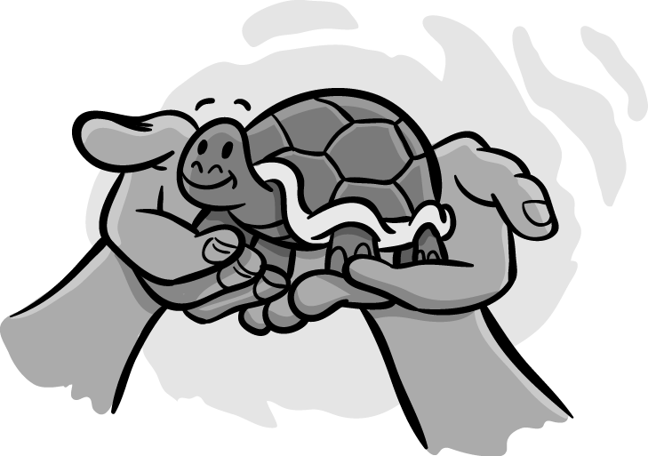

- This is my turtle.
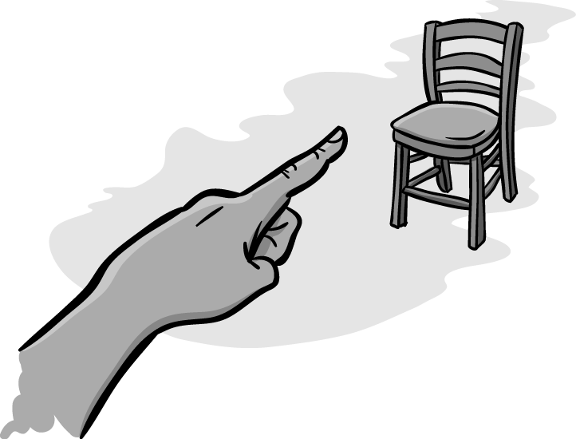

2 ___________________________________.
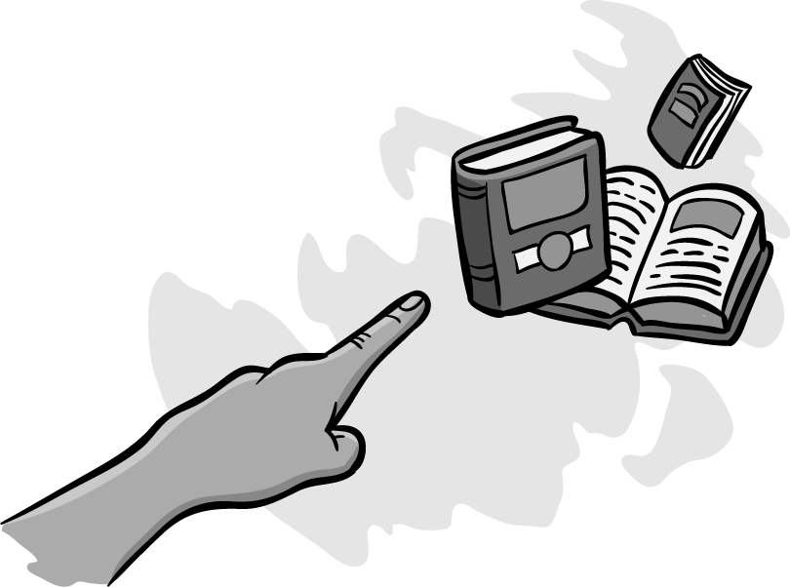

3 ___________________________________.


4 ___________________________________.


5 ___________________________________.
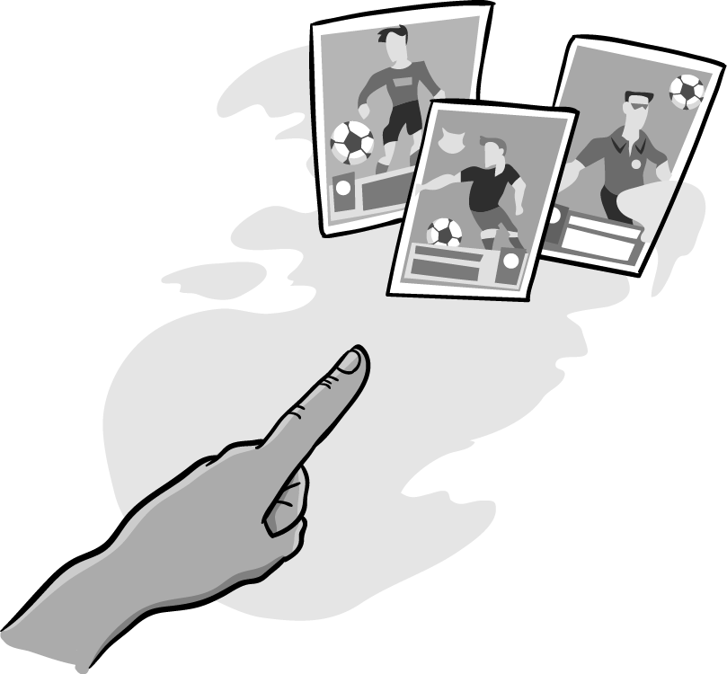

6 ___________________________________.

 | _____ | 5
6 Complete the words.

1 s t i c k e r


2 k _ y _ i _ g

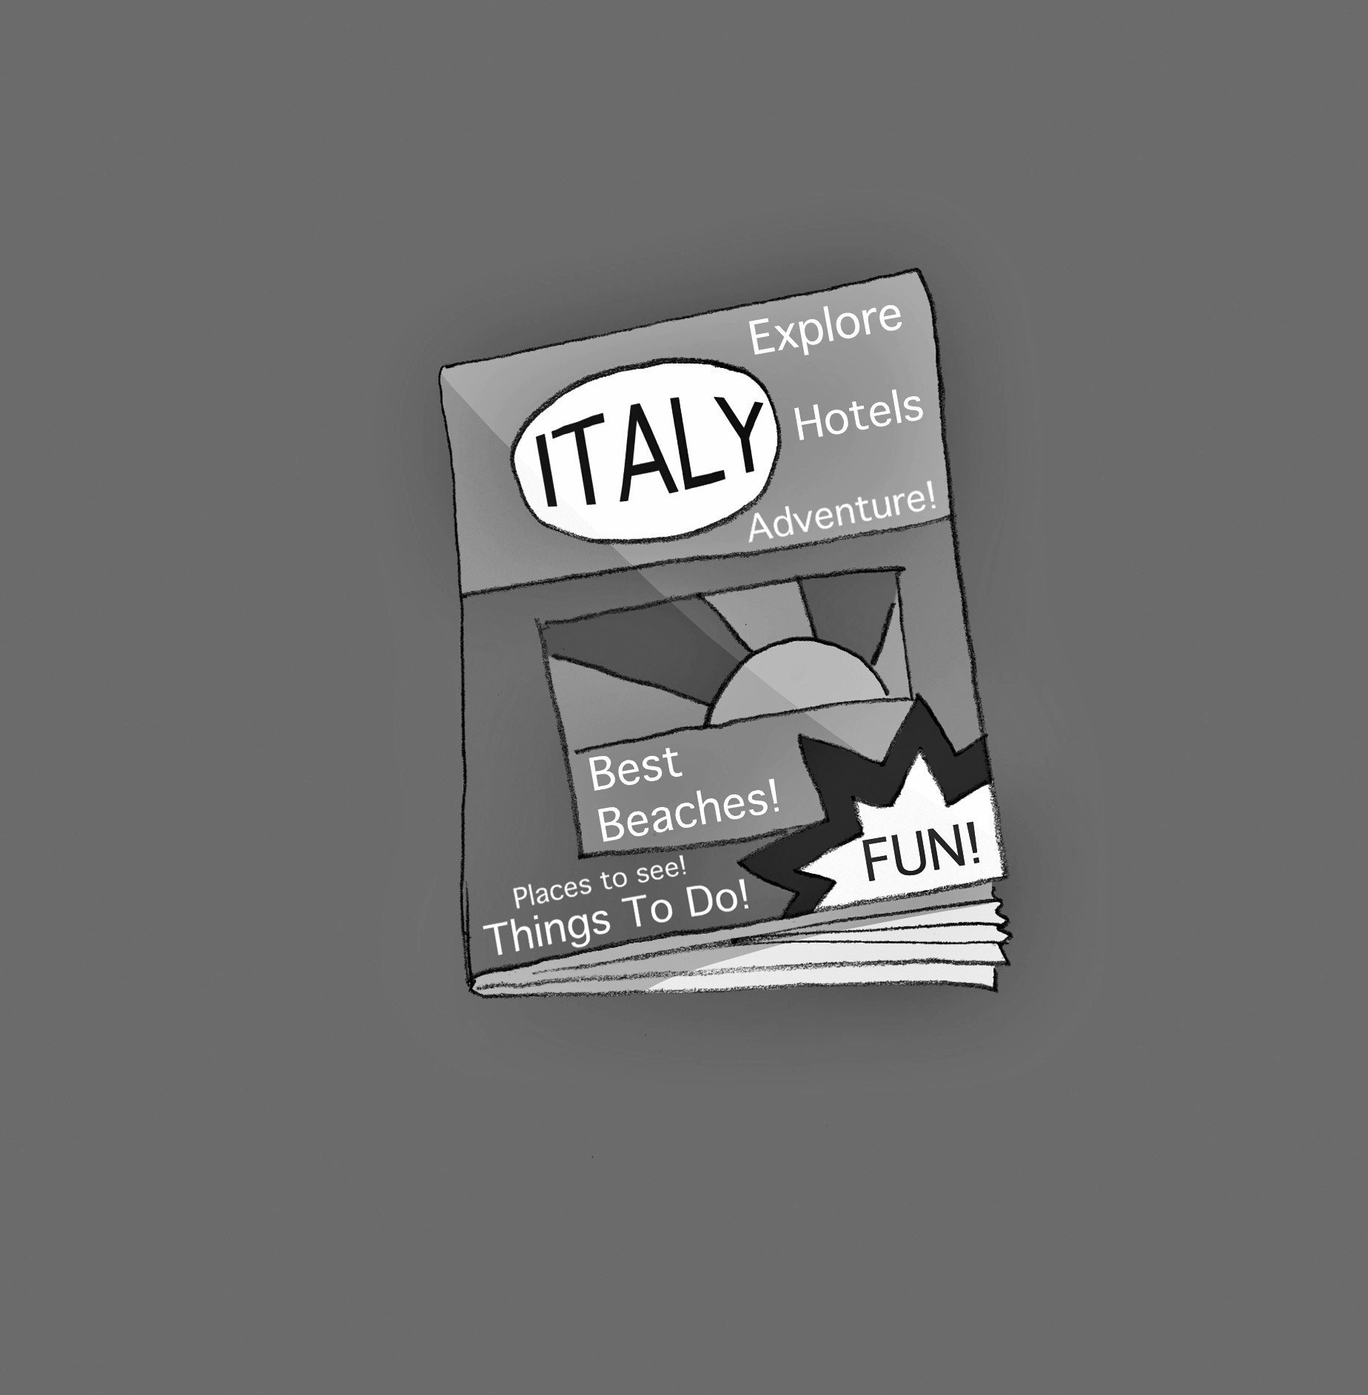
3 m _ g _ z _ n _


4 f _ s _ i _


5 b _ d _ e

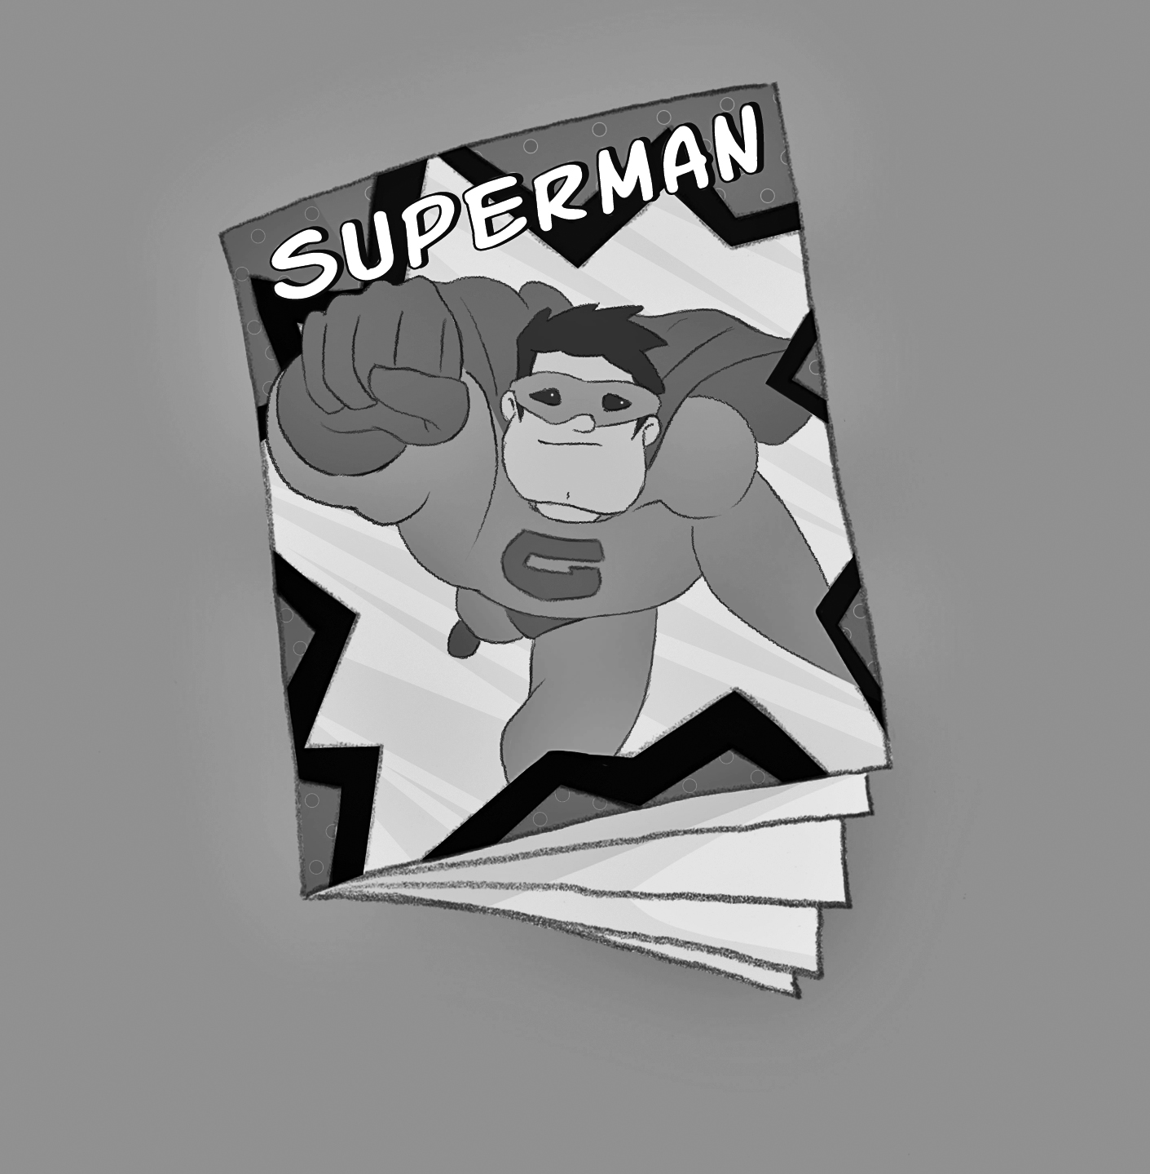
6 c _ m _ c

 | _____ | 5

7 Complete the sentences with the words in the box.
box floor laptop posters room shelf
1 I’m in my room.
2 My fossils are in a ____________.
3 My ____________ are on the wall.
4 My books are on the ____________.
5 My ____________ is on the desk.
6 My rug is on the ____________.

 | _____ | 5
8 Complete the dialogues with the phrases in the box.
can I borrow can I have can I take of course OK you can’t
1 A I’m thirsty. ¹Can I have some water?
B Yes, ²____________. Here you are.

2 A I love this magazine. ³____________ it home?
B ⁴____________. Give it to me on Friday.

3 A This is a great game. ⁵____________ it?
B Sorry, ⁶____________. It’s my sister’s game.

 | _____ | 5

 | Total |  | 50

