MY DAILY ROUTINE AND FREE TIME

DAILY ROUTINE
Mandy Taylor is twelve years old and she’s a student at Stratford High School in New Zealand. She loves her classes. Her favourite subjects are Science and Physical Education. She is very good at sports. She plays ice hockey at the school’s female team.
Mandy has a busy life. She always gets up at 6:00 am during the week and she has a shower. She brushes her teeth, gets dressed, has breakfast and at 7:00 she goes to school with her mother.
On Mondays, Mandy often has lunch at school with her friends, on Tuesdays and Thursdays she practices ice hockey at the school’s gym. On Fridays she goes to the cinema with her friends. Wednesday is Mandy’s favourite day of the week because she has dance classes and sometimes she has dinner with her father. Mandy’s parents are divorced. She lives with her mother and at the weekends she always goes to her father’s house.
On Saturdays Mandy wakes up at 7:15 am. After breakfast she goes to the park with her dog. She has lunch with her father at 12:30. At 3:20 pm she goes to the city’s library and reads some books. She usually meets some friends at the library. At 4:40 pm Mandy goes home and listens to music in her bedroom. She loves music. At 9:45 pm she goes to bed. She never goes to bed late.
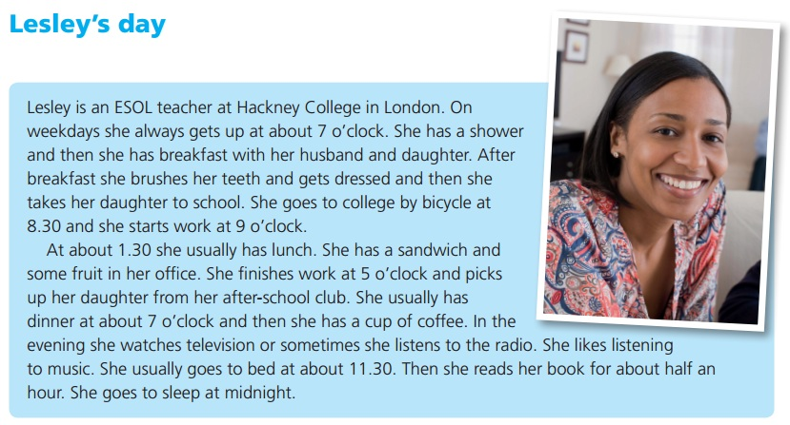

NOW IT’S YOUR TURN!!!

  - What do you usually do during the week?
Talk about your daily routine ( I get up at ..., I have breakfast and I drink..., I go to school at.... by..... , I come back home at….. and I have lunch…I eat….; in the afternoon I …., after dinner I…., I go to bed at… etc.)

  - What do you usually do in your free time and at the weekends? Where do you go? ( On Saturday afternoon I ……., on Sunday I get up at … and then I …)
  - What do you like doing in your free time? ( I like listening to music, going out with my friends because…, playing videogames, going to the oratory….etc).

  - What sports do you like and which ones can you do?
( I like tennis, but I can’t play it because.... I like swimming, it’s tiring but amusing and I can swim quite well, I go swimming twice a month in ..... because in my village the swimming- pool is open only in summer....I hate football, I like skiing.. but I’m not very good at it ...etc..)

  - How often do you practise it/them? Do you play in a team?

