THE FAMILY
MOTHER
FATHER
GRANDFATHER
GRANDMOTHER
BROTHER
SISTER
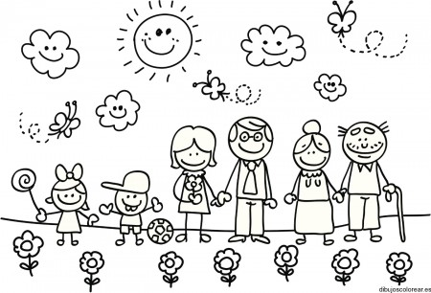
Write the names in the correct box
_ _ _ _ _ _ _
_ _ _ _ _ _ _ _ _ _ _

_ _ _ _ _ _ _ _ _ _ _

_ _ _ _ _ _

_ _ _ _ _ _

_ _ _ _ _ _

