British English vs American English

The British and the Americans both speak English but they don't always use the same words.

Activity 1 → Match these American words with the pictures.
a trunk / an eraser / a hood / an egg-plant / a movie theatre / cotton candy / subway
a can / a truck / restrooms / a trash can / an elevator / trash / French fries
 | British English | American English |  |  | British English | American English
 | chips |  |  | 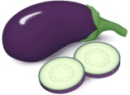 | an aubergine
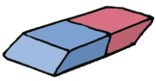 | a rubber |  |  | 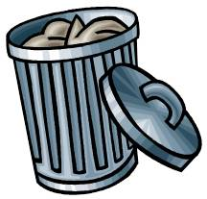 | a bin
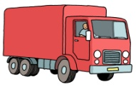 | a lorry |  |  | 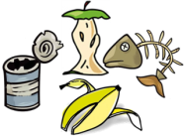 | rubbish
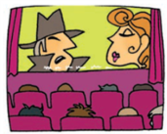 | a cinema |  |  | 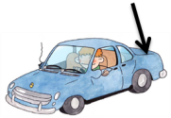 | the boot
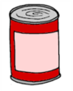 | a tin |  |  | 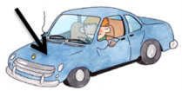 | the bonnet
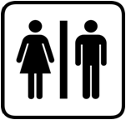 | public toilets |  |  | 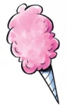 | candy floss
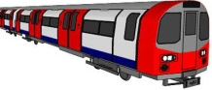 | underground |  |  | 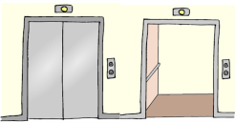 | a lift

Activity 2 → Match the British words with the American words. Mind the odd-one-out !

GB |  | US
pudding •  flat •  post •  torch •  car park •  postman • |  | • mail  • store  • mailman  • parking lot  • flashlight  • dessert  • apartment
Activity 3 → Is the word English or American ? Tick the correct flag.

Mom |  | 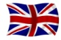 |  | 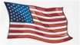 |  |  | petrol
Mum |  |  |  |  |  |  | gas
cookies |  |  |  |  |  |  | fizzy drink
biscuits |  |  |  |  |  |  | soda
mobile phone |  |  |  |  |  |  | pajamas
cellphone |  |  |  |  |  |  | pyjamas
police car |  |  |  |  |  |  | post code
patrol car |  |  |  |  |  |  | zip code
mustache |  |  |  |  |  |  | crisps
moustache |  |  |  |  |  |  | potato chips
Activity 4 → Paraphrase the British sentences using the American words below.

the faucet / movie / suspenders / after /candies / bathroom / do the dishes / Fall / kids
the check / sneakers / the highway / vacation / the sidewalk / line / the shopping mall

It is the best film I have ever seen.
→ ______________________________________________________
On October 31st, it's Halloween. Children get a lot of sweets when they say "trick or treat".
→ _________________________________________________________________________________
I have drunk so much water, I really need to go to the toilet.
→ _________________________________________________________________________________
There are lots of lorries on the motorway today.
→ _________________________________________________________________________________
There is a long queue of people waiting at the bus stop.
→ _________________________________________________________________________________
White trainers are fashionable this summer.
→ _________________________________________________________________________________
It's ten past two. → __________________________________________
My grandfather used to wear striped braces to keep his baggy trousers up.
→ _________________________________________________________________________________
I am on holiday for a week and I will return to work next Monday.
→ _________________________________________________________________________________
I'm going to the shopping centre, do you want to come with me ?
→ _________________________________________________________________________________
You mustn't ride your bike on the pavement !
→ _________________________________________________________________________________
I do the washing-up every day after dinner.
→ _________________________________________________________________________________
Waiter ! Could you please bring me the bill ?
→ _________________________________________________________________________________
Autumn is my favourite season.
→ ________________________________________________________
Turn off the tap when you clean your teeth.
→ ___________________________________________________________________
Activity 5 → British words can sometimes be really different from American words.
Read these American words. What do they mean in GB ? What do they mean in the US ? Write GB or US next to the correct picture. Look at the example first. | the first floor | 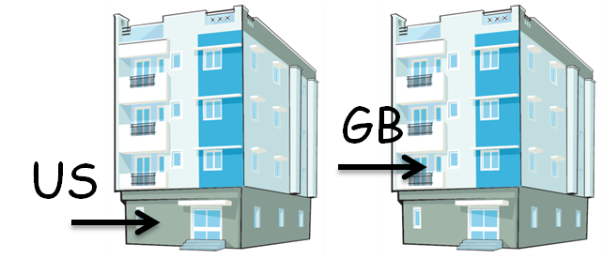

to wash up | 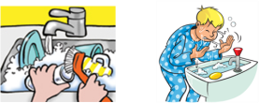 | a lavatory | 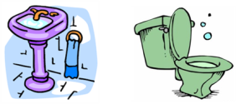
chips | 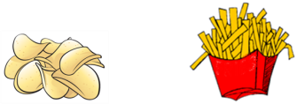 | pants | 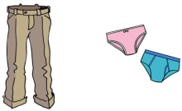
football | 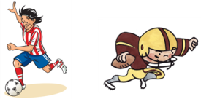 | a vest | 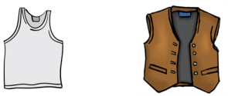
jelly | 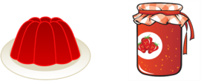 | a purse | 