POLOLETNÍ OPAKOVÁNÍ Z ANGLICKÉHO JAZYKA – 3. TŘÍDA
- WRITE NUMBERS 1-10
ent -……………………… neo - ……………………… isx - ………………………………..
gheit - ……………………… rethe - …………………… oufr - ……………………………..
wot - ……………………… evesn - ……………………… veif - …………………………….
inen - ………………………

- COMPLETE THE TABLE
YESTERDAY | TODAY | TOMORROW
 | SATURDAY
 | FRIDAY
 | THURSDAY
 | MONDAY

- WRITE: There is/There are
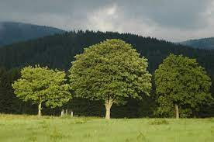
…………………………………….. A TENT.
………………………………… THREE FLOWERS.
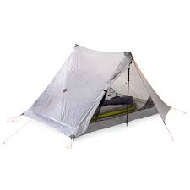
………………………………… SOME TREES.
……………………………………. A RIVER.

- WHAT´S THE WEATHER LIKE TODAY? COMPLETE THE SENTENCES. USE: SNOWY, WINDY, SUNNY, CLOUDY, RAINY
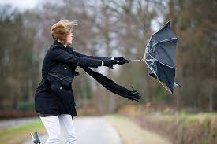
- IT IS …………………………… TODAY.
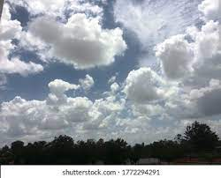
- IT IS …………………………… TODAY.

- IT IS ……………………………… TODAY.
- IT IS …………………………… TODAY.
- IT IS …………………………… TODAY.

