[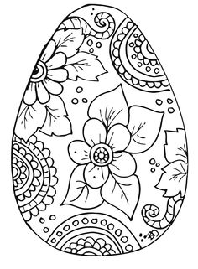](https://www.google.cz/url?sa=i&rct=j&q=&esrc=s&source=images&cd=&ved=0ahUKEwjNsMOonu3SAhVEDSwKHRvbBIwQjRwIBw&url=https%3A%2F%2Fwww.pinterest.com%2Fcreamalice%2Fprintable-coloriages%2F&bvm=bv.150475504,d.bGg&psig=AFQjCNHUJDl-SdAfyvyEWZHj7UB5aWS-LA&ust=1490379219050315)[](https://www.pinterest.com/lila_boudreaux/easter/)Co jsou Velikonoce? Jak probíhají jarní oslavy u Vás?

[](https://www.google.cz/url?sa=i&rct=j&q=&esrc=s&source=images&cd=&cad=rja&uact=8&ved=0ahUKEwjK7pnrnu3SAhUGjSwKHTGZB48QjRwIBw&url=https%3A%2F%2Fwww.pinterest.com%2Flila_boudreaux%2Feaster%2F&bvm=bv.150475504,d.bGg&psig=AFQjCNHUJDl-SdAfyvyEWZHj7UB5aWS-LA&ust=1490379219050315)[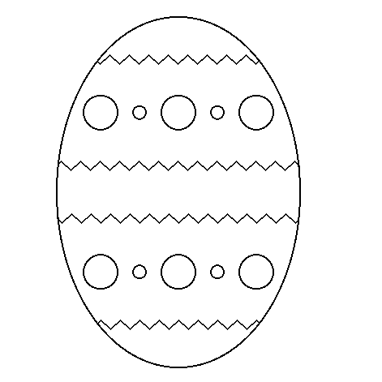](http://www.google.cz/url?sa=i&rct=j&q=&esrc=s&source=images&cd=&cad=rja&uact=8&ved=0ahUKEwjI9JSdn-3SAhVJECwKHcm9B5IQjRwIBw&url=http%3A%2F%2Fwww.predskolaci.cz%2Fvelikonocni-kraslice%2F5220&bvm=bv.150475504,d.bGg&psig=AFQjCNHUJDl-SdAfyvyEWZHj7UB5aWS-LA&ust=1490379219050315)