C L O T H E S
S | K | I | R | T | E | H | A | T | H | I | P | O
W | A | I | S | H | I | R | T | R | O | U | Y | R
E | A | B | A | C | K | P | A | N | T | S | J | T
A | J | I | S | H | A | R | F | B | E | S | A | I
T | I | E | S | H | O | R | T | S | E | L | M | E
E | B | O | A | T | S | E | F | V | E | R | A | W
R | O | O | M | N | K | N | O | M | S | I | S | S
B | U | I | O | C | S | L | D | R | E | S | E | J
S | H | O | A | T | G | L | R | V | O | O | C | C
U | N | J | E | A | S | O | E | H | H | N | O | O
I | L | B | S | O | C | K | S | S | S | R | G | A
T | R | O | U | S | E | R | S | F | B | E | L | T

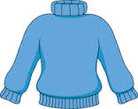
SKIRT PYJAMAS SWEATER

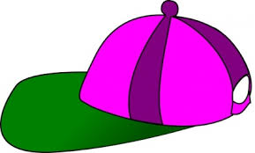
WAIST SCARF SHORTS

SUIT TROUSERS BELT
SOCKS COAT SHOES
GLOVES JACKET BOOTS
DRESS PANTS JEANS
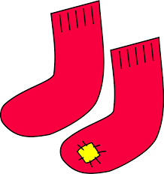
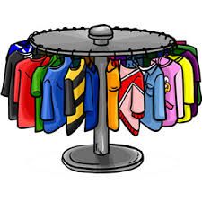
TIE HAT
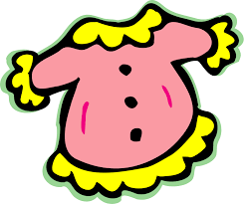

What are you wearing?
- 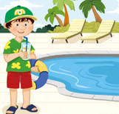  Where is he?  ___________________________________.  What’s he wearing?  He’s ________________________________.  3. 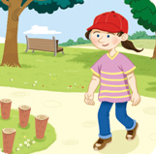  Where is she?  ________________________________________.  What’s she wearing?  She’s __________________________________.  5.  Where _____ _______?  _________________________________________  What ____ ______ wearing?  _______________________________________.  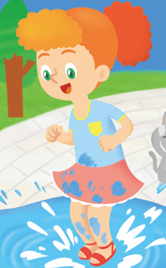 What is she____________?  ____________________________________________. | - 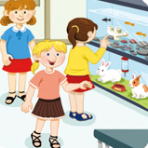  Where are they?  ___________________________________.  What are they wearing?  They’re_______________________________.  4.  Where is he?  _______________________________________.  What’s he wearing?  ________________________________________.  6. 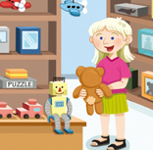  Where ____ _______?  _______________________________________.  What’s _____ ___________?  _______________________________________.  What is he_____________?  _____________________________________________.

