- Třída – AJ - jídlo

Food
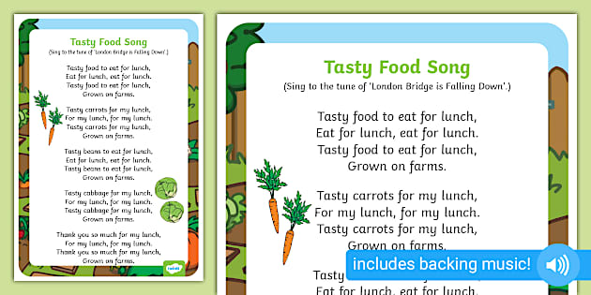
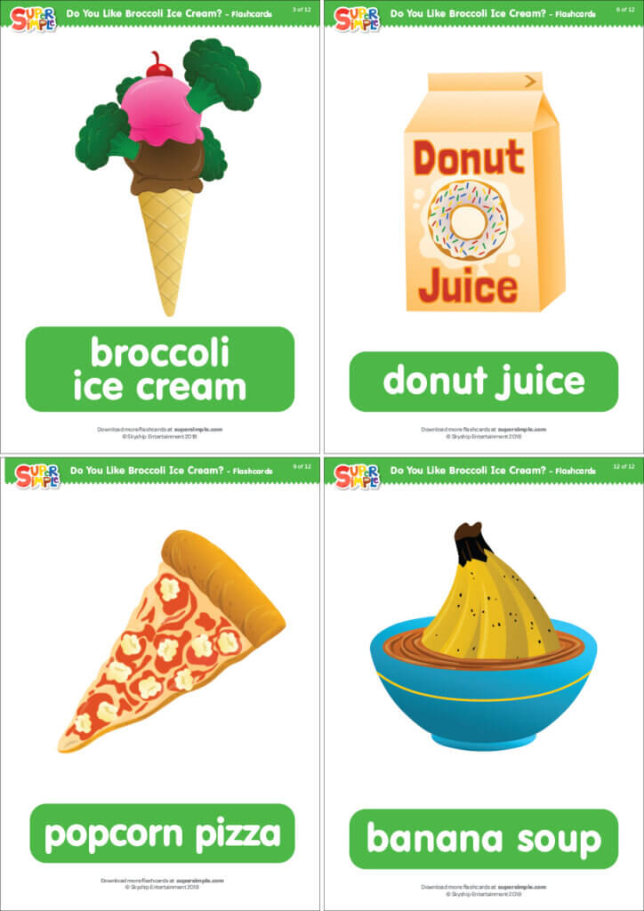
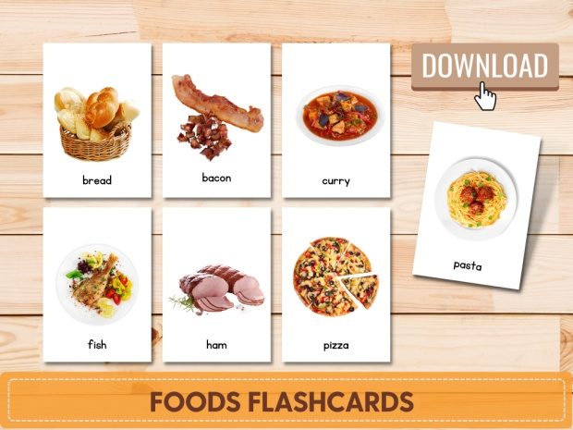
Songs
- Do You Like Broccoli Ice Cream?
- I Like to Eat Apples and Bananas
Vocabulary
- apple, banana, ice cream, bread…
Activities
- (I like / I don’t like)
- Sort food pictures

