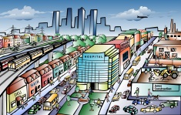
PLACES IN TOWN
Where can you do the following activities? Fill in.
a bank___
a cinema___
a church___ ______
a a hospital m)

a supermarket___
a hotel___ centre
a square___
a park___
a cafe___
a museum___
a station ___
a swimming pool___
a sports centre____
a shop___
a post office___

- meet someone f) get some coffee k) spend a night
- buy milk g) swim l) pray
- relax h) exercise m) get better
- see old artefacts i) watch a movie n) buy clothes
- buy stamps j) withdraw money o) catch a train
Place/Místo Activity/Činnost
e.g./např.
a hospital m ) get better

